###### HOSTEL MANAGEMENT SYSTEM

###### CAPSTONE DESIGN PROJECT REPORT

Submitted by

**ESAKKI RAJAN E (18C025)**

**GOPIKA B (18C029)**

**SAMS AAFIYA BANU S (18C088)**

in partial fulfillment for the award of the degree of

#### BACHELOR OF ENGINEERING

***in***

###### COMPUTER SCIENCE AND ENGINEERING

##### THIAGARAJAR COLLEGE OF ENGINEERING, MADURAI – 15

(A Government Aided Autonomous Institution Affiliated to Anna University)



#### ANNA UNIVERSITY: CHENNAI 600 025

###### NOV 2021

### THIAGARAJAR COLLEGE OF ENGINEERING MADURAI-15

(A Government Aided Autonomous Institution Affiliated to Anna University)



#### BONAFIDE CERTIFICATE

Certified that this project report “**Hostel Management System”** is the bonafide work of **“ESAKKI RAJAN E (18C025), GOPIKA B (18C029), SAMS AAFIYA BANU S (18C088)** who carried out the project work under my supervision during the Academic Year 2021-2022.

**SIGNATURE SIGNATURE**

Dr.S.Mercy Shalinie, M.E., Ph.D., Guide Name With Qualification

**HEAD OF THE DEPARTMENT SUPERVISOR & DESIGNATION**

COMPUTER SCIENCE AND ENGINEERING COMPUTER SCIENCE AND ENGINEERING THIAGARAJAR COLLEGE OF ENGG. THIAGARAJAR COLLEGE OF ENGG.

MADURAI – 625 015 MADURAI – 625 015

Submitted for the VIVA VOCE Examination held at Thiagarajar College of Engineering on ………………

**INTERNAL EXAMINER EXTERNAL EXAMINER**

**Acknowledgement**

I wish to express my deep sense of gratitude to **Dr.M.Palaninatharaja,** Principal of Thiagarajar College of Engineering for his support and encouragement throughout this project work.

I wish to express my sincere thanks to **Dr.S.Mercy Shalinie**, Head of the Department of Computer Science and Engineering for her support and ardent guidance.

I owe my special thanks and gratitude to **Guide Name**, Designation, Department of Computer Science and Engineering for his /her guidance and support throughout our project.

I am also indebted to all the teaching and non-teaching staff members of our college for helping us directly or indirectly by all means throughout the course of our study and project work.

I extremely thank my parents, family members and friends for their moral support and encouragement for my project.

**ABSTRACT**

**“HOSTEL MANAGEMENT SYSTEM**” is a software developed for managing various activities in the hostel. For the past few years the number of educational institutions are increasing rapidly.

Thereby the number of hostels are also increasing for the accommodation of the students studying in this institution. And hence there is a lot of strain on the person who are running the hostel and software’s are not usually used in this context.

This particular project deals with the problems on managing a hostel and avoids the problems which occur when carried manually.

Identification of the drawbacks of the existing system leads to the designing of computerized system that will be compatible to the existing system with the system which is more user friendly and more GUI oriented.

**TABLE OF CONTENTS**

1. INTRODUCTION
   1. PROJECT OVERVIEW
   2. PROJECT OBJECTIVES
2. PROBLEM STATEMENT
3. EXISTING SYSTEM

3.1 TABLE COMPARISON

1. METHODOLOGY
   1. ARCHITECTURAL DIAGRAM
2. IMPLEMENTATION
   1. LOGIN MODULE
   2. REGISTRATON MODULE
   3. UPDATE MODULE
   4. BOOK HOSTEL ROOM MODULE
   5. ROOM DETAILS MODULE
   6. ROOM ALLOCATION MODULE
   7. ADD ROOM MODULE
   8. MANAGE ROOM MODULE
   9. USER ACCESS LOG MODULE
3. REQIUREMENTS ANALYSIS AND SPECIFICATION

6.1 SOFTWARE CONFIGURATION

6.2 HARDWARE CONFIGURATION

1. DATA DESIGN
   1. ENTITY RELATIONSHIP DIAGRAM
   2. CONCEPTUAL SCHEMA
2. ENTITIES AND ATTRIBUTES
   1. HOSTEL
   2. ADMINSTRATOR
   3. STUDENT
   4. ROOM
   5. VISITORS
   6. FURNITURE
3. RESULT AND DICUSSION
4. INTRODUCTION

**1.1 Project overview:**

The online hostel management system is web based software to provide college students accommodation to the university hostel more efficiently. This project also keeps details of the hostellers and applied students. Hostel Room allocation system is a web application which aims at computerization of current procedure of allocating hostel rooms. Currently the process involves students filling up the forms and submitting them in respective hostel offices which involves a lot of paperwork, hence less efficient.

Hostel Room allocation system is a web application which aims at computerization of current procedure of allocating hostel rooms. Currently the process involves students filling up the forms and submitting them in respective hostel offices which involves a lot of paperwork, hence less efficient. Hostel Management in schools often involves administering of all activities of students.

All these still remains difficult and require some job for the top management. Hostel Management functions and responsibilities in modern day schools have always been a problem in managing, because of the manual system method of tools they use. Hostel Management System is well designed specially to meet challenges of administrative set up of any school. It can be used to assist in student’s allocation, setup hostel information, hostel application, student outing record and visitor management. In short, this system will assist the staff in managing the hostel management at school.

**1.2 PROJECT OBJECTIVES :**

* To deal with Hostel Management System in an easy and an efficient manner.
* Create strong and secrete database that allow for any connection in a secret way, to prevent any outside or inside attacks.
* Students can register their complaints.
* Room Process allotment list.

1. **Problem Statement:**

Despite advancement in technology, there are still hostels in many institutions in the world who are still using manual system to manage the hostels. The difference between computer and humans is that computers are faster and accurate which reduces mistakes.

To provide a computerized management system for Hostels that will replace the manual allocation method. Identification of the drawbacks of the existing system leads to the designing of computerized system that will be compatible to the existing system with the system which is more user friendly and more comfortable.

We can improve the efficiency of the system. In the current manual system, it will very difficult to find the hostel record and other information of student manually. Because it has been keep on the paper and it is easy to loss. It also consume time to search the paper of student hostel record one by one. The manual system requires longer time for allocation the student to respective hostel, dorm, and bed.

Besides that, the manual application will lead toward a hassle data management for faster student allocation as well as managing the data for faster task such as student’s activities, student outing record and managing visitors.

1. **EXISTING SYSTEM :**

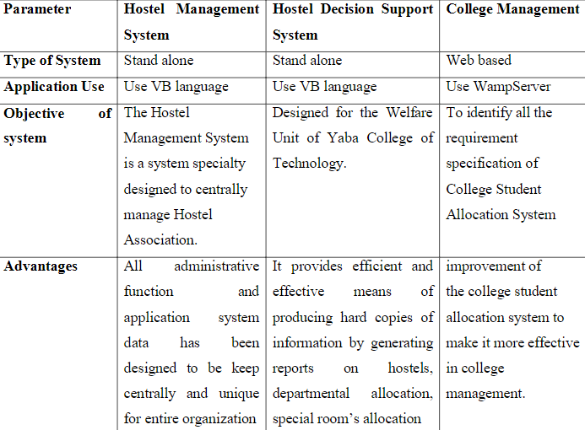

1. **METHODOLOGY:**

We are going to implement this system with the help of a **web application** that supports all the functionalities in a hostel administration.

* 1. **Architectural Diagram**

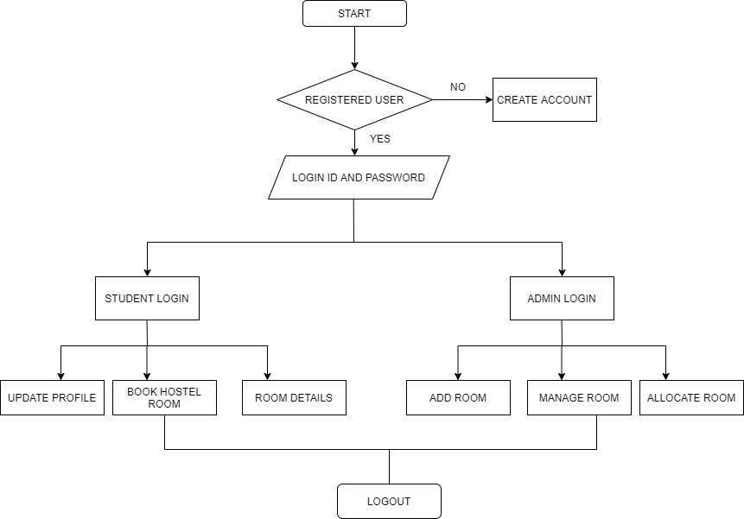

1. **IMPLEMENTATION:**

**5.1 Login Module:**

The user can login with the credentials and is validated. If the user doesn’t have any account he can create a new account.

* User Login
* Admin Login

**5.2 Registration Module:**

The user can create a new account and login with it in this module.

**5.3 Update Module:**

This module is used to update the user details like name, phone number, mail id and password of the user.

**5.4 Book Hostel Room Module:**

In this module, Students can book their rooms according to their convenience by filling the required details.

**5.5 Room Details:**

In this module, Students would be able to view the room related information and also print those information.

**5.6 Add Room Module:**

In this module, admin can add rooms along with type of seater.

**5.7 Allocate Room Module:**

In this module, admin can allocate rooms to the student.

**5.8 Manage Room Module:**

This module facilitates the admin to allocate or deallocate rooms of the students.

**5.9 User Access Log Module:**

This module would record the user access with login time and date.

1. **REQUIREMENT ANALYSIS AND SPECIFICATION:**

**6.1 HARDWARE CONFIGURATION**

The section of hardware configuration is an important task related to the

Software development insufficient random access memory may affect adversely on the speed and efficiency of the entire system. The process should be powerful to handle the

Entire operations. The hard disk should have sufficient capacity to store the file and application.

Processor : Pentium IV and above

Processor speed : 1.4 GHz Onwards

System memory : 128 Mb minimum 256 Mb recommended

Cache size : 512 KB

RAM : 512 MB (Minimum)

Network card : Any card can provide a 100mbps speed

Network connection : UTP or Coaxial cable connection

Printer : Inkjet/Laser Color printer provides at least 1000 Dpi

* 1. **SOFTWARE CONFIGURATION:**

A major element in building a system is the section of compatible software since the software in the market is experiencing in geometric progression. Selected software should be acceptable by the firm and one user as well as it should be feasible for the system.

This document gives a detailed description of the software requirement specification. The study of requirement specification is focused specially on the functioning of the system. It allow the developer or analyst to understand the system, function to be carried out the performance level to be obtained and corresponding interfaces to be established.

Front end tool : HTML, CSS, JAVASCRIPT.

Backend : PHP MYSQL

Frame Work :

Operating system : Windows 2009/2010

1. **Data Design: ( DBMS )**

## Entity Relationship Diagram

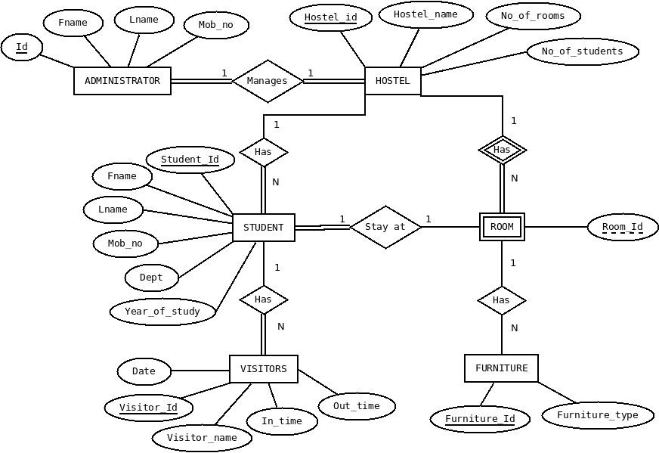

* 1. 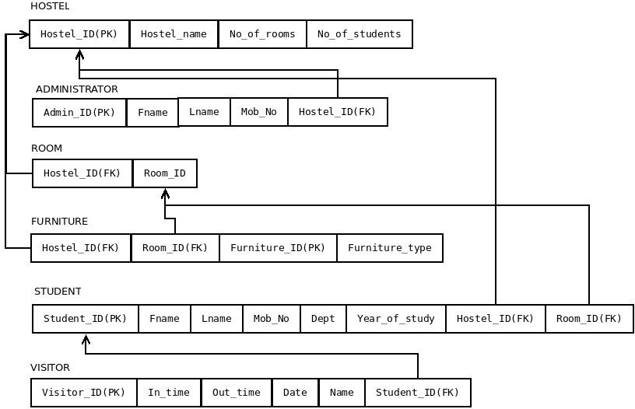 **Conceptual Schema**

1. **Entities and Attributes**

This section of the document explains the entities used in the project, their attributes and how they will work together. Basically, this is intended to make the design more easy and understandable for everyone.

#### 8.1 Entities

1. Hostel
2. Administrator
3. Student
4. Room
5. Visitor
6. Furniture

## Hostel

An Institution has many hostels and each hostel is represented using this ‘Hostel’ entity. Hostel model takes part in the following relationships.

* + 1. Administrator manages **Hostel**.
    2. **Hostel** has Students.
    3. **Hostel** has Rooms.

#### Attributes

|  |  |  |
| --- | --- | --- |
| **Name** | **Data Type** | **Type** |
| Hostel_ID | integer | Primary Key attribute |
| Hostel_name | string | Non_key attribute |
| No_of_rooms | integer | Non_key attribute |
| no_of_students | integer | Non_key attribute |

## Administrator

Every hostel has an administrator and is represented using the ‘administrator’ entity. Administrator entity takes part in following relationships.

* + 1. **Administrator** manages Hostel.

#### Attributes

|  |  |  |
| --- | --- | --- |
| **Name** | **Data Type** | **Type** |
| ID | integer | Primary Key attribute |
| Fname | string | Non_key attribute |
| Lname | string | Non_key attribute |
| Mob_No | string | Non_key attribute |
| Hostel_id | integer | Foreign Key attribute |

## Student

Every hostel has students and they are represented by the ‘student’ entity. Student entity participates in the following relationships.

* + 1. Hostel has **Students**.
    2. **Student** has visitor.
    3. **Students** stay at room

#### Attributes

|  |  |  |
| --- | --- | --- |
| **Name** | **Data Type** | **Type** |
| Student_ID | integer | Primary Key attribute |
| Fname | string | Non_key attribute |
| Lname | string | Non_key attribute |

|  |  |  |
| --- | --- | --- |
| Mob_No | string | Non_key attribute |
| Dept | string | Non_key attribute |
| Year_of_study | integer | Non_key attribute |
| Hostel_id | integer | Foreign Key attribute |
| Room_id | integer | Foreign Key attribute |

## Room

Every Hostel has rooms and they are represented using ‘room’ entity. Room entity participates in the following relationships.

* + 1. Hostel has **Rooms**.
    2. Student stays at **room**.
    3. **Room** has Furniture.

#### Attributes

|  |  |  |
| --- | --- | --- |
| **Name** | **Data Type** | **Type** |
| Hostel_ID | integer | Foreign Key attribute |
| Room_ID | integer | Partial Key attribute |

## Visitors

Every student has visitors and they are represented using ‘Visitor’ entity. Visitor entity participates in the following relationships.

* + 1. Student has **visitors**.

#### Attributes

|  |  |  |
| --- | --- | --- |
| **Name** | **Data Type** | **Type** |
| Visitor_ID | integer | Primary Key attribute |
| In time | Date-time field | Non_key attribute |

|  |  |  |
| --- | --- | --- |
| Out time | Date-time field | Non_key attribute |
| Date | Date-time field | Non_key attribute |
| Name | string | Non_key attribute |
| Student_id | integer | Foreign Key attribute |

## Furniture

Every room has furniture and they are represented using ‘furniture’ entity. Furniture participated in following relationships.

* + 1. Room has **Furniture**.

#### Attributes

|  |  |  |
| --- | --- | --- |
| **Name** | **Data Type** | **Type** |
| Furniture_ID | integer | Primary Key attribute |
| Room_ID | integer | Foreign Key attribute |
| Hostel_ID | integer | Foreign Key attribute |
| Furniture_type | string | Non_key attribute |

**10.Results and Discussion:**